Week 6 Reading
Complete the following reading early in the week:
- Week 6 online lectures.
In case you're using max bones and IK solvers, read:
- The following sections from the 3ds Max Help section:
  - Using Dope Sheet Editor and on Setting Parameter Out-of-Range Types (within the Bouncing Ball tutorial in Introduction to Animation)
  - Producing Lip Sync Animation
- Review the textbook 3ds Max 2010 Bible, as needed to reinforce and expand on the concepts and techniques required for this week’s assignments.
Note: Within 3ds Max on the Help pulldown choose Tutorials. In the Contents window expand the Character Animation listing —> Character Animation without Biped —> Animating a Character —> Merging Animation.
Week 6 Assignments Overview
Assignment Summary: Week 6 | Due Date
Assignment 1: Discussion Questions | Monday, May 10, 2010
Assignment 2: Final Project—Animating Your Camera | Monday, May 10, 2010
Assignment 3: Final Project—Reviewing the Movie | Tuesday, May 11, 2010
Assignment 4: Final Project—Managing Assets and Organizing Files | Wednesday, May 12, 2010

Week 6 Overview
How was the last week? Did you get any sleep? Did you finish your rendering? Did the character you created measure up to your expectations? When an animation comes off, you feel great, and love being an artist. But when you first render your animation, there will be things to fix. Animation is an iterative process; this week is your turn to iterate.

This week, you'll look at how to improve the animation you did last week. You'll review the tools and techniques for adjusting animation timing and using 3ds Max time configuration and trackbar features. You'll also discuss the use of Graph Editors Track View and Dope Sheet for controlling and adjusting timing. You'll receive some tips for improving your rendering, and then end with a review of how to use sound in your keyframing. Adding sound to your animation can make your movie more artistic and lifelike.

Learning Outcomes:
- Analyze project art needs and control all files and assets.
- Create 2D and 3D computer animation.
- Create a short 10-second animation with character face counts of 1000 polygons or less.
Controlling Timing
Rescale Time
3ds Max provides some simple and direct methods to adjust the timing of your animation. You can manipulate the frame count and range to re-scale the time using the Time Configuration dialog. This is particularly effective if you have lots of different animated characters appearing in a shot simultaneously. This re-scaling method affects all the different animations that you've created for each character.
Click on the RHS link to download detailed lectures on controlling timing using theRe-scale Time option.
Track View
3ds Max comes with two Graph Editors that use the Track View. They are theTrack View—Curve Editor and the Track View Dope Sheet. Curve Editor and Dope Sheet allow you to have complete control of the timing of your animations. We assume you are familiar with the basics of these modules, so we won't do an introductory review.
Click on RHS link to download detailed lectures on controlling timing using theTrack View option.
[Lecture File – GAD415_W6_Rescale Time, GAD415_W6_TrackView]
Dope Sheet
You use the Curve Editor to work on individual components of your characters' animation, and then use Dope Sheet to adjust the timing of the animation as it relates to other scene events.
Dope Sheet is like the trackbar at the bottom of the viewport, it shows keys and ranges. Unlike the trackbar, it can show keys for multiple objects in columns and rows, rather than on top of each other as in the Trackbar.
You can directly access Dope Sheet from the right-click menu in 3ds Max. Pick the object in the viewport, right-click and pick Dope Sheet.
Dope Sheet has two modes, Edit Keys and Edit Ranges. Edit Ranges mode lets you show key ranges just like in the trackbar. In Edit Keys mode, Dope Sheetcolor codes the keys so you can easily identify position vs. rotation vs. scale keys.
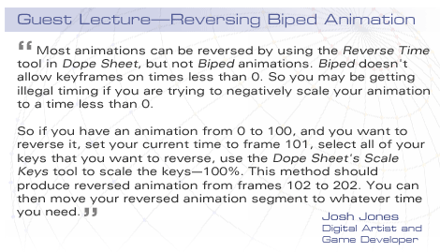
[Lecture File - GAD415_W6_DopeSheet]

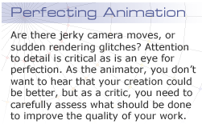
Improving Your Animation and Rendering
The process for improving your animation and rendering is simple enough. After you have finished your first rendering, create a movie, and watch it. Evaluate the movie for a number of different things.
First does the movie do what you wanted it to do? Does it satisfy the objective you set out to achieve? You have a low-poly character that is performing an action. Does the viewer see the movie and get that? If you think you've made an animation of a dog doing a victory dance, does the user recognize that it's a dog and not a horse? Does the user know it's a victory dance and not an epileptic fit? Have you in other words succeeded in creating personality and character via motion, which is the heart of animation?
Next you need to evaluate the animation from a technical standpoint. Is there anything in the technique that sticks out like a sore thumb? Does your model behave correctly or are there frames where the character suddenly shows its polygons? Does the rigging need adjusting? You want your Computer Graphics (CG) technique to be transparent; it should support the movie, rather than call attention to itself. Are there places where the keyframing needs work, or requries further work on the materials, lighting, effects, etc.?
Note: Computer Graphics (CG) technique should be “invisible.” The work should not draw attention to itself; it should support the movie, not compete with it. The purpose of the rendered movie is for the students to show off their low-poly modeling.
It's often a good idea to show your animation and rendering to a friend, co-worker, or just anyone else who's available. Get their opinion. You may be surprised that what is important to you is not even on their radar screen. You may be focused on some detail on the model and the viewer doesn't even see them.
Make sure that the animation shows off the work you did. Make sure the mood of the animation matches what you want to portray. The finished animation should create the desired effect. Otherwise make changes.
Laziness is your number one enemy at this stage and lack of time ranks second. There is never enough time to fix everything you want to fix, so be ready to accept less than perfection. Be willing to go back to a step that needs attention, even if it means a lot of work.
Also look at your work on several different systems. Different monitors have different levels of brightness and contrast, and sometimes you'll find your movie which looked great on the monitor in the office, looks drab or dark on your computer at home. Try to design your work so it can stand a variety of setups and still have a strong overall affect.

As a rule, never render to movie file format. If you find there are ranges that need re-rendering, at least you may not have to re-render the entire sequence. It's one thing if you have a render farm at your disposal, but if you have a single computer you don't want to render the entire thing again if you don't have to.

Adding Sound to Complete your Animation
3ds Max lets you add a soundtrack to your animation by creating a track in Track View. Let's suppose you're going to create a musician playing the hand drums. You can animate the character drumming to a rhythmic beat. In Track View —>Curve Editor directly under the World track you'll find the Sound entry. Right-click, pickProperties from the popup menu and then click on Choose Sound. Here we have a file called Teka.wav that displays a waveform like this:
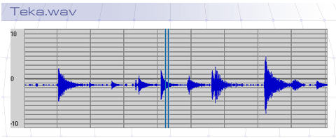
Once you have a soundtrack chosen, the waveform will display in the Graph Editor and you will be able to see the keyframes from your animation in the same graph as the sound. It becomes easy to synchronize the movement of your characters to the soundtrack by simply repositioning the keyframes visually to line up with the spikes in the waveform. Hold down the CTRL key and select the soundtrack and the animation track you wish to match. The two tracks will display in the same window. Here, the rotation track for the drummer's wrist is displayed over the waveform.
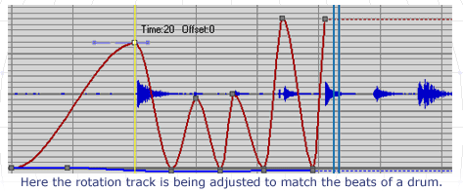
If you know the animation is going to have to match a soundtrack, you can also start with a soundtrack and then add a keyframe to it. Alternately, you can keyframe and then record the sounds while the animation plays onscreen, usingMicrosoft Sound Recorder that comes with Windows, or any other sound recording program that is available.

The soundtrack can be shifted to match the keyframes, by moving the soundtrack range bar in Track View—>Dope Sheet.
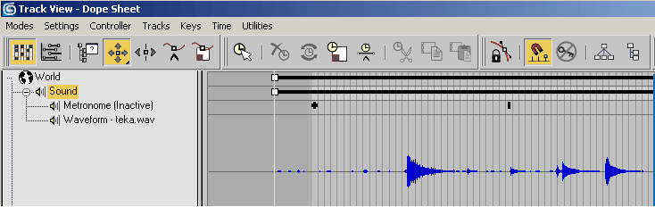
When you add a soundtrack to Track View, this track will be used by VideoPost or by the renderer provided you render to a movie format that supports sound, such as AVI or MOV.
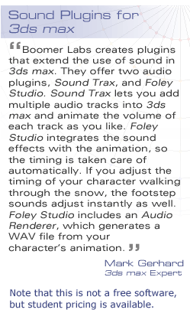
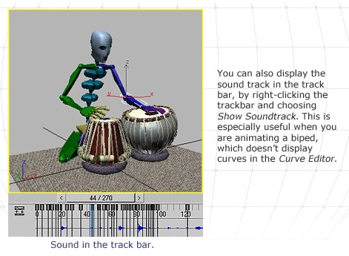
Visit Boomer Labs: http://www.boomerlabs.com/

Course Conclusion
In this class, you've explored the different methods 3ds Max offers for modeling and controlling them to produce low-poly models. You've looked at best practices while modeling, so that your characters are sufficiently articulated to handle animation, and yet still meet the requirements set out by the game programmers you work with.
You also discussed techniques to reduce polygon count manually and using modifiers. You've also seen methods to reduce detail by using materials and mapping, including image planes, opacity mapping, bump, and normal mapping. You've had a chance to review the techniques of animation using 3ds Max, and looked at methods to control timing and add sound to your finished rendering. You have probably also built and textured a nice character model to add to your portfolio.
As you move into your life as a 3D CG artist, here are some tips and tricks. Remember that the customer is always right, and your customer is the games company you work for. Learn from fellow artists. They may have learned things the hard way, learning from them will be the “easy way” for you. Trust your instincts and communicate with your team members. Most failures are caused by faulty communication.

You are a creative individual expected to come up with and executing great ideas. But don't be attached to these ideas, they will get shot down for different reasons. If you need total creative control, start your own company because in the real world, you'll be part of a large industrial art machine and you'll have to march lock-step with the others, or suffer the consequences.
Never stop learning! This is the key to being a good artist and animator. Soak in knowledge and skill from everyone around you and you will enjoy your work. Make an effort to figure out how to be a great artist and yet be a good co-worker.
Realize that your personal artistic aspirations may not be satisfied working for a large company. Leave your personal creativity to evenings and weekends at home or in your studio. You'll be happier if you don't expect your job to fill this need for you.
Also keep a perspective on what you do and the affect it has on the world. We can get so caught up in the technology we use, we forget our humanity. Young impressionable children will be playing your games; before you know it your children will be playing these games. Take care what you put in their heads—it will come back round in many ways.
Most of us don't become artists, we recognize we are artists. We pursue this career because we have no choice. This is who we are. There is a payoff in the creation of the art, a satisfaction that has nothing to do with money or status. It is closer to the joy that a parent has in watching their child mature, or a gardener seeing their labors yield bountiful harvest.
Remember that part of this work; it is a secret that is shared among all creative people. You are one of a special breed for the creative energy of the universe manifests itself in you directly. Use this energy wisely! Good luck for your future!

Assignment 1: Discussion Questions
By Monday, May 10, 2010, respond to the discussion questions assigned to you by your Facilitator. Submit your responses to the appropriate Discussion Area. Start reviewing and responding to your classmates' discussions as early in the week as possible.
Grading Criteria | Maximum Points
Response Criteria
Met the criteria for the correct responses to the questions assigned. | 6
Used vocabulary relevant to the current week's topics—at least five terms. | 6
Participation Criteria
Used vocabulary relevant to the current week's topics—at least five terms. | 6
Participated in the discussion by asking a question, providing a statement of clarification, providing a point of view with a rationale, challenging a point of discussion, or drawing a relationship between one or more points of the discussion. | 6
Justified ideas and responses by using appropriate examples and references from texts, Web sites, other references, or personal experience. | 6
Total: | 30
For assistance with any problems you may have when completing this assignment—OR—to offer your assistance to classmates, please use theProblems and Solutions Discussion area located through the left side navigation link.
What do you think should be the parameters for reviewing a movie? Do you agree with your peers' responses? Why or why not? Give reasons.
What should you look for when critiquing a classmate’s animations? Respond to the posts of at least 2 classmates. I look forward to an interesting discussion!
- Todd
When critiquing any piece of work, we need to look at both the idea and execution from an artistic and technical standpoint. From the artistic standpoint, From the traditional standpoint, does the animation have a strong design? A good color palette? Does it follow the 12 principles of animation? Does the design of the character and environment work separately and do they support each other together? Does the character move smoothly and believably? Is there good timing, anticipation and follow through? Is the actual movement interesting and captivating?
Technically one should look for errors related to 3d studio: Is there texture or mesh stretching? Is the motion too stiff or automatic? Too fast or too slow? Are there errors in rendering that need to be addressed?
So what do I look for when critiquing a students animation? I look to see if the student has successfully incorporated what they learned in the online lecture and readings or successfully implemented an alternative method. One of the books I have on rigging and animation stated that it can take months or years to master 3ds max’s rigging and biped functions so I will be more than forgiving to students who have been asked to learn the entire animation system in 2-3 days. That said, I look to see if the student has successfully animated their character beyond the basic footstep tool. I look for the use of techniques of using bone tools and IK chains or the more intricate use of keyframe tools in biped to animate the limbs and entire body. If they can show an example of substantial progress from their first attempt, I would say the animation is successful.

Assignment 2: Final Project—Animating Your Camera
Last week, you animated your game character. This week, you need to animate your camera.
Create your 10-second animation by revolving a camera around your animated character over 300 frames. By Monday, May 10, 2010, save as .MAX file and post the file to the appropriate Discussion Area.
Make sure that your game character is not more than 1,000 polygons.
Note: 30 frames per second is the standard frame rate. So if you need a 10-second animation, you'll have to create 300 frames.
Once you're through with animating your camera, re-render your animation.
Grading Criteria | Maximum Points
Posted a .MAX file with an animated camera and animated character over 300 frames. | 10
Created a character that is not more than 1,000 polygons. | 10
Re-rendered the animation. | 10
Total: | 30
For assistance with any problems you may have when completing this assignment—OR—to offer your assistance to classmates, please use theProblems and Solutions Discussion area located through the left side navigation link.

Assignment 3: Final Project—Reviewing the Movie
You discussed the parameters for reviewing 3D animation and the movie. Now with the help of your facilitator, finalize by mutual agreement the checkpoints essential for the review of a movie.
Using that same checklist of parameters, review and comment on the animations posted by at least two other students.
Based on the feedback you received from your classmates, revise your animation and render again to create a new version incorporating the suggestions.
Write a paragraph about the feedback you got, and what you did to respond to it.
By Tuesday, May 11, 2010, post the animation as .MOV or .AVI file to your W6: Assignment 3 Dropbox.
Grading Criteria | Maximum Points
Posted .MAX files (3D Animation). | 5
Posted movie files (.AVI or .MOV—2D Animation). | 5
Created a character with not more than 1,000 polygons. | 10
Posted iterations of files. | 10
Explained and responded to the feedback received. | 10
Total: | 40
For assistance with any problems you may have when completing this assignment—OR—to offer your assistance to classmates, please use theProblems and Solutions Discussion area located through the left side navigation link.

Assignment 4: Final Project—Managing Assets and Organizing Files
Using the matrix supplied, list all the project files you have used until now. Mention the various files and assets used in your Final Project with their latest details.
By Wednesday, May 12, 2010, post your asset management file to the appropriateDiscussion Area.
Grading Criteria | Maximum Points
Posted a list of all project asset-related files. | 15
Reviewed and commented on at least two students' asset management files. | 15
Total: | 30
For assistance with any problems you may have when completing this assignment—OR—to offer your assistance to classmates, please use theProblems and Solutions Discussion area located through the left side navigation link.

